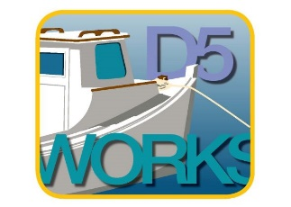
2019 America’s Boating Club Mid-Atlantic District 5
Summer Council and Rendezvous
25-28 July 2019 * Crisfield, MD

MEMBER

Rank Name Grade

Address City State Zip ___________

Phone E-mail Squadron

SPOUSE/OTHER ATTENDEES
Rank Name Grade
Rank Name Grade
Rank Name Grade

ACTIVITY FEE (Required per person except children 12 and under-free)
Covers all fees, # ____ @ $ 5.00 $ ________

FRIDAY Golf Tournament (Greens Fee & Cart) # ____ @ $25.00 $ ________
FRIDAY Tangier Island Cruise (1200-1700/Lunch on your own) # ____ @ $27.00 $ ________
SATURDAY NIGHT BBQ BUFFET
Per Adult # ____ @ $25.00 $ ________
Per Child (12 & Under) # ____ @ $15.00 $ ________

BBQ Pork Ribs, BBQ Chicken,
1/4 Lb. Angus Hamburgers
On buns, Baked Beans,
Sweet Corn on the Cob, Cole Slaw,
Assorted Cakes, Iced Tea, Bottled Water

TOTAL ENCLOSED $________
Reservations must be submitted by 18 July 2019.

Make checks payable to: USPS District 5

PLEASE SEND RESERVATIONS WITH CHECKS TO:

D/Lt Apryl Bernard
1127 Riverside Drive, Mays Landing, NJ 08330
(609) 432-7449 aprylber@msn.com

Marina Reservations: For hotel recommendations
Somers Cove Marina, Crisfield, MD Please check the website
www.somerscovemarina.com/reservations.html www.uspsd5.org
1-800-967-3474 ask for Mary.

