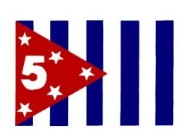

**2025 D/5 Summer Cruise and Rendezvous**

**14 – 19 July 2025 Smith Mountain Lake, VA**

**Member:** Rank____ Name____________________________ Grade_____

Address _____________________________________________________

Squadron_____________________ Position___________ First Timer?___

eMail____________________________________ Phone______________

**Spouse/Other Attendees:**

Rank____ Name________________________ Grade_____ First Timer?____

Rank____ Name________________________ Grade_____ First Timer?____

**14-17 July - Smith Mountain Lake Cruise**

Participating? Yes ___ No ___

Houseboat ___ or Other ___

Who is the Captain and Crew? ____________________________________

______________________________________________________________

______________________________________________________________

**17-19 July - Rendezvous at Mariners Landing**

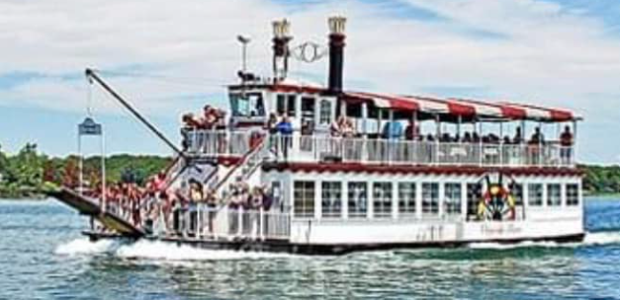

**Special Offering – Charter Cruise on the Virginia Dare**

If we can meet the minimums, the Virginia Dare will be chartered Thursday for a 6:00 – 8:00 pm dinner / sightseeing cruise. Tickets will be purchased on board but we need a firm count to commit to the charter. If Interested, indicate your commitment by selecting one of the options below:

#____ Sightseeing cruise with dinner on board $50 + tax + $3 tip

#____ Sightseeing cruise only $35 + tax + $3 tip

**17-19 July - Rendezvous at Mariners Landing (continued)**

Registration Fee #_____ @ $10 = $ ______

**Saturday Morning** #_____ @ $5 = $ ______

Guided Tour of the National D-Day

Memorial & War Museum following the

District Flag Raising and Meeting

**Saturday Night**

Resort Buffet Dinner Hosted by #_____ @ $65 = $ ______

Tiff’s at Mariners Landing.

Variety of delicious mains, garden

vegetables, sides, desserts and

beverage.

Total Enclosed: $ ________

**Meal Reservations must be received by 30 June**

Dress Codes: Friday - Squadron Shirts; Saturday Flag Raising: Uniform D or E; Saturday Dinner: Squadron/District Shirts or Appropriate Attire

HOUSEBOAT RENTALS: PARROT COVE MARINA

16441 Booker T. Washington Hwy Moneta, Virginia

(540) 721-5363 [www.parrotcove.com](http://www.parrotcove.com)

MAKE LODGING RESERVATIONS DIRECTLY WITH MARINERS LANDING, 1217 Graves Harbor Trail, Huddleston, Va 24104, Call 540-297-4100 + option 1

[www.marinerslanding.com](http://www.marinerslanding.com)

or use AirBnB or VRBO for additional options.

Make Checks Payable to: SMLSAPS

Send to:

Celinda Moening

109 Sunset Pointe Dr

Moneta, VA 24121-2149

Additional Information

On the D5 Website

