**D5 Rendezvous - Smith Mountain Lake**

**14-20 July 2025**

7/14 Monday - Board Houseboats

* Provision and Underway… or stay at Pelican Point and join on Tuesday
* 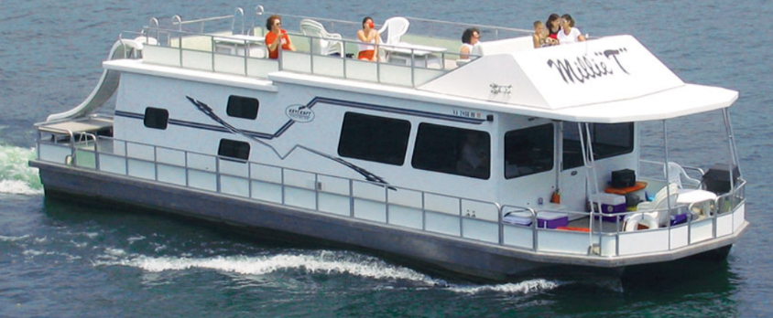Shake down cruise
* Evening Mooring - SML State Park
* Travel - ~ 7 miles

7/15 Tuesday

* Cruise to Smith Mountain cove
* Swimming & fellowship
* Pitch-in Social
* SML Squadron Support Vessels
* Travel ~ 5 miles

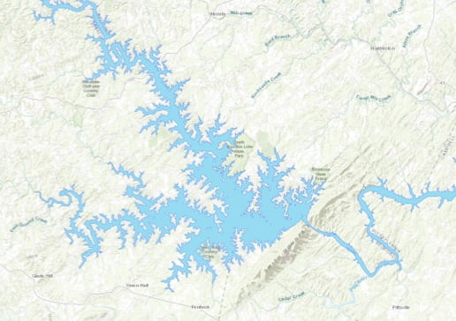7/16 Wednesday

* Cruise to Goodhue Blackwater (Crazy Horse)
* Ice Cream Boat in route?
* Moored ~ 1600
* Restaurant - shore bar and dinner available
* Evening Entertainment
* Travel ~ 7 miles

7/17 Thursday

* Cruise Back to Parrot Cove
* Hot Dog Boat or Ice Cream Boat in route?
* Transition to Mariners Landing
  + Welcome Area
  + 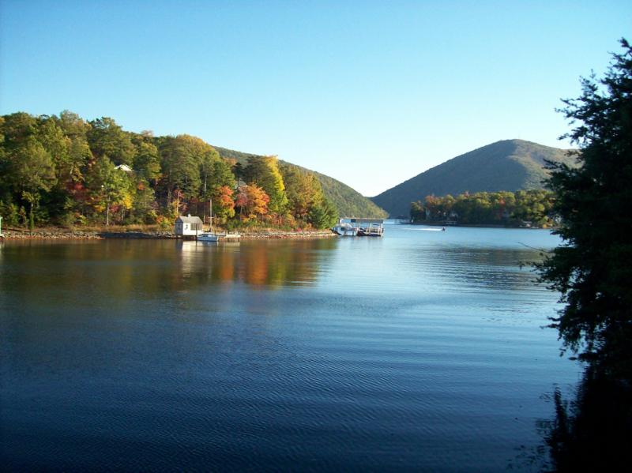Evening on your own
* Optional Event: Virginia Dare Dinner Cruise?
  + Charter Option Available (no regular cruise on Thursdays)
    - 23 people minimum w/ food $50 + tax + $3 gratuity
    - 33 people minimum w/o food $35 + tax + $3 gratuity

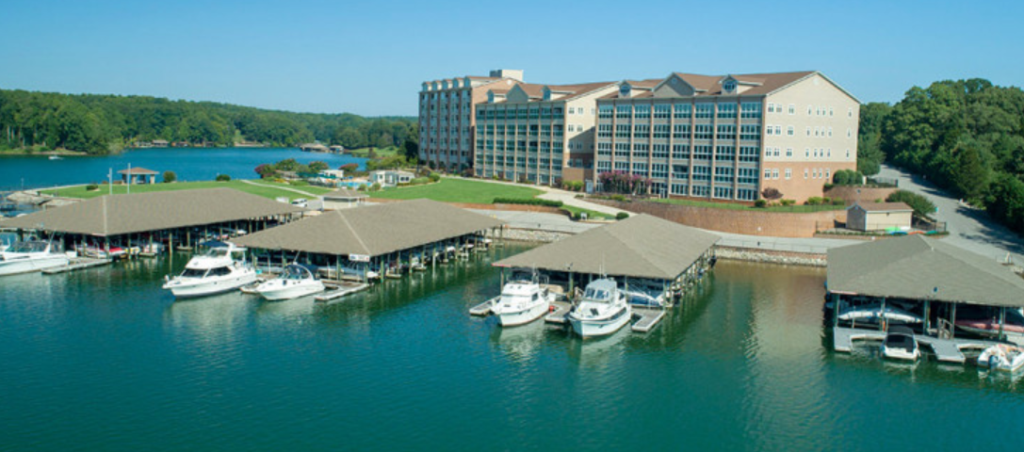

7/18 Friday

* Activities
  + Raffle / 50/50
  + Water Games (Pool or Swim Area)
  + Various independent games
  + Crafts
  + Golf Avavilable
  + Pickle ball lessons / tourney
* 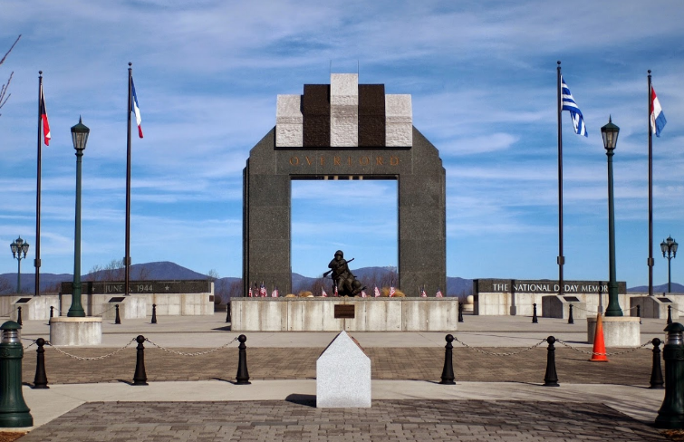ACBS Participation?
* D/C Reception
* Dinner on your own
* Conference Room is Open

7/19 Saturday

* Flag Raising - D-Day Memorial
* District 5 meeting / Recognition and awards
* 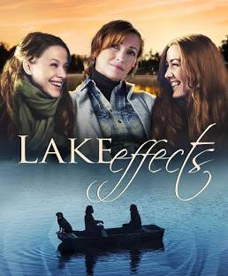D-Day Tours
* Independent Lunch - Biels.. Liberty Station... etc
* Independent activities in the afternoon
* Banquet with Cash Bar
* Special Movie Night
  + *Lake Effects* – hosted by a movie producer, actor, and previous Miss Virginia bringing the film to life at Smith Mountain Lake



More?

D5 Website